**A**

**Mini Project Report**

**On**

**“Cricket PoseNet : AI Shot Recognition”**

Submitted by

**Mohd Umair (22733)**

Submitted to

**Prof. Aasha Singh**

**Prof. Kriti Chaurasiya**

For Partial Fulfilment of Award of Degree

In

**Masters of Computer Application**

at



Department of Computer Science & Engineering

**Kamla Nehru Institute of Technology, Sultanpur**

# Affiliated to Dr. A.P.J. Abdul Kalam Technical University, Lucknow

# December, 2023

# **Table of contents**

**1. Introduction**

1.1 Background…………………………………………………………………..……5

1.2 Problem Statement…………………………………………………………...……5

1.3 Objectives………………………………………………………………...………..5

1.4 Scope of the Project………………………………………………………………..5

**2. Literature Survey**

2.1 Overview of Cricket Shot Classification……………………………………..……6

2.2 Deep Learning in Sports Analytics………………………………………………..6

2.3 Fast API and Its Applications……………………………………………………...6

2.4 Computer Vision in Sports Technology…………………………………………...6

2.5 Detectron Framework…………………………………………………………...…7

2.6 ReactJS and Tailwind CSS in Frontend Development………………………….…7

**3. Methodology Used**

3.1 Overview of Methodology……………………………………………………...…8

3.2 Data Collection and Preprocessing…………………………………………..……8

3.3 Deep Learning Model Architecture………………………………………………..8

3.4 Integration of Fast API………………………………………………………….....8

3.5 Implementation of Detectron for Computer Vision……………………...………..9

3.6 Frontend Development with ReactJS and Tailwind CSS…………………...……..9

**4. System Requirements Specifications**

4.1 Functional Requirements…………………………………………………………10

4.2 Non-functional Requirements……………………………………………………10

4.3 Software and Hardware Requirements………………...…………………………11

4.4 Constraints………………………………………………………………..………12

**5. Design**

5.1 Overview Design…………………………………………………………………13

5.2 Workflow Diagram……………………………………………………….………13

5.3 Process Flow Diagram………………………………………………………...…14

5.4 Data Flow Diagram………………………………………………………………15

**6. Implementation**

6.1 Frontend……………………………………………………………………….…16

6.2 Backend…………………………………………………………………..………26

6.3 Integration of Components……………………………………….………………32

6.4 Testing……………………………………………………………………………32

**7. Results and Data Analysis**

7.1 Accuracy………………………………………………………………………….34

7.2 Classification Report……………………………………………………..………34

7.3 Confusion Matrix……………………………………………………………...…35

7.4 Training and Validation Loss curves…………………..…………………………36

7.5 Analysis………………………………………………………………………..…36

**8. Conclusion**

8.1 Summary of Achievements………………………………………………………37

8.2 Challenges Faced…………………………………………………………………37

8.3 Lessons Learned…………………………………………………………….……37

**9. Future Work**

9.1 System Enhancements……………………………………………………………38

9.2 Scalability and Maintenance……………………..………………………………38

**References**

**Introduction**

Welcome to "Cricket Posenet : AI Shot Recognition", your ultimate destination for cricket enthusiasts and passionate fans of the sport. Our innovative website is designed to revolutionise the way you experience cricket by bringing cutting-edge technology and real time data analysis to your fingertips.

It is not just another cricket website, it's a game-changer that combines the thrill of cricket with the power of artificial intelligence. With our state-of-the-art image recognition technology, we can tell you which shot a batsman has played in an uploaded image, providing an interactive and insightful experience like never before.

This project is dedicated to the precise classification of cricket shots, employing cutting-edge technologies like Detectron2 and Deep Learning within the realm of advanced computer vision. A fundamental aspect of Computer Vision, known as Pose Detection, assumes a pivotal role in this endeavour. It involves the sophisticated prediction of the positions and postures of individuals or objects captured within images. The primary aim of this undertaking is to categorise cricket shots based on the specific poses adopted by players in the images.

By harnessing the combined capabilities of Pose Detection and Deep Learning, we unlock the ability to not only identify the type of cricket shot being executed but also to derive invaluable insights for cricket analysis and training. It's akin to having a perceptive eye that can instantly recognize and categorise a wide array of cricketing actions.

This project employs a multi-faceted approach, encompassing deep learning methodologies, extensive data augmentation techniques, and rigorous model training procedures. This ensures that the model becomes adept at generalising across various player poses and shot types. Through these techniques, the model achieves a high level of proficiency in recognizing and classifying cricket shots with a remarkable degree of accuracy. Ultimately, this project aspires to yield a robust and automated solution for cricket shot classification, poised to offer indispensable support for coaches, analysts, and cricket enthusiasts seeking profound insights into the game.

**1.1 Background**

Cricket shot classification is a pivotal aspect of modern sports analytics, offering deep insights into player performance. Traditionally, this process has been manual, time-consuming, and subjective. This project addresses these challenges by leveraging cutting-edge technologies such as deep learning, computer vision, Fast API, ReactJS, and Tailwind CSS to automate and enhance the cricket shot classification process.

**1.2 Problem Statement**

Manual shot analysis in cricket is prone to human error, lacks real-time insights, and can be overwhelming when dealing with vast amounts of data. The aim is to automate this process, providing a faster, more objective, and efficient means of shot classification.

**1.3 Objectives**

* Develop a robust deep learning model capable of accurately classifying various cricket shots.
* Implement a backend using Fast API to facilitate seamless communication between the frontend and the deep learning model.
* Utilise Detectron for computer vision tasks, enabling precise shot localization and extraction.
* Create an intuitive and user-friendly frontend using ReactJS and Tailwind CSS to visualise and interact with the classification results.
* Perform shot analysis to support coaches, players, and analysts in making informed decisions.

**1.4 Scope of the Project**

The project focuses on automating the classification of common cricket shots, such as flick, drives, pull shots, and cut shots. The scope encompasses the end-to-end process, from data collection to frontend visualisation.

# **Literature Survey**

Cricket shot classification and sports analytics have been subjects of extensive research and exploration in recent years. This literature review aims to provide a brief overview of key topics related to cricket shot classification, deep learning applications in sports analytics, and the technologies employed in this project.

**2.1 Overview of Cricket Shot Classification**

Cricket shot classification involves identifying and categorising various shots played by batsmen during a match. Traditional methods rely on manual tagging, which is time-consuming and subjective. Recent advancements leverage machine learning and computer vision to automate this process, enhancing accuracy and efficiency.

**2.2 Deep Learning in Sports Analytics**

Deep learning has emerged as a powerful tool in sports analytics. In the context of cricket, it enables the creation of sophisticated models capable of recognizing patterns in player behaviour. The utilisation of deep neural networks for shot classification has shown promising results, allowing for real-time analysis and insights.

**2.3 Fast API and Its Applications**

Fast API, a modern web framework for building APIs with Python, facilitates the development of robust and high-performance backend systems. Its asynchronous capabilities are particularly advantageous for applications demanding quick responses, making it a suitable choice for the real-time requirements of this cricket shot classification project.

**2.4 Computer Vision in Sports Technology**

Computer vision plays a pivotal role in sports technology, providing the ability to analyze visual data such as image feed. In cricket, computer vision techniques, including object detection and tracking, are instrumental in precisely identifying and extracting shots played by batsmen.

**2.5 Detectron Framework**

Detectron, an open-source object detection library developed by Facebook AI Research (FAIR), is widely used for computer vision tasks. Its flexibility and efficiency make it an ideal choice for shot localization in this project. Detectron's pre-trained models can be fine-tuned to accurately identify key points in the player.

**2.6 ReactJS and Tailwind CSS in Frontend Development**

ReactJS, a JavaScript library for building user interfaces, combined with Tailwind CSS, a utility-first CSS framework, offers a modern and efficient approach to frontend development. The component-based structure of React simplifies the creation of interactive and dynamic user interfaces, while Tailwind CSS provides a utility-centric styling approach, enhancing frontend design flexibility.

.

# **Methodology Used**

**3.1 Overview of Methodology**

The development of the cricket shot classification system involves a systematic approach, encompassing data collection, preprocessing, model training, backend implementation, and frontend development. The methodology aims to seamlessly integrate deep learning, computer vision, and web technologies.

**3.2 Data Collection and Preprocessing**

**Data Source:** Cricket shot datasets, containing labelled examples of various shot types, were collected from reliable sources. These datasets form the foundation for training the deep learning model.

**Preprocessing:** The collected data underwent preprocessing to remove noise and ensure uniformity. Image data for computer vision tasks was resized, normalised, and augmented to enhance the model's generalisation capabilities.

**3.3 Deep Learning Model Architecture**

**Model Selection:** A deep neural network architecture suitable for image classification tasks was chosen. The model underwent iterative development and fine-tuning to optimise its performance in accurately classifying cricket shots.

**Training:** The model was trained on the labelled datasets, with a focus on achieving high accuracy and minimising false positives and false negatives in shot classification.

**3.4 Integration of Fast API**

**Backend Development:** Fast API was employed to develop the backend of the system. API endpoints were created to facilitate communication between the frontend and the deep learning model. Asynchronous features of Fast API were utilised to ensure responsive real-time interactions.

**Model Integration:** The trained deep learning model was integrated into the Fast API backend, enabling seamless classification of shots based on user inputs.

**3.5 Implementation of Detectron for Computer Vision**

**Detectron Integration:** The Detectron framework was employed for precise shot localization and extraction keypoints in the player's image. This was crucial for accurate shot classification. The integration involved adapting pre-trained models to suit the specific requirements of cricket shot analysis.

**3.6 Frontend Development with ReactJS and Tailwind CSS**

Frontend development is a crucial aspect of the cricket shot classification system, as it directly influences how users interact with and interpret shot classification results. In this section, the implementation details of the frontend, built using ReactJS and styled with Tailwind CSS, are elaborated upon.

**3.6.1 UI/UX Design**

ReactJS Components:

* Input Forms: User-friendly forms are created for users to upload images for shot classification. These forms capture user inputs and initiate requests to the backend for real-time processing.
* Shot Classification Results: Components for visualising shot classification results are designed to provide a clear and concise presentation. Dynamic elements allow users to interact with and explore the data.

**3.6.2 Tailwind CSS Styling:**

* Utility-First Approach: Tailwind CSS's utility-first approach is utilized for styling components, offering a streamlined and consistent design process.
* Responsive Design: Tailwind CSS enables the creation of responsive designs, ensuring optimal user experience across various devices and screen sizes.

# **System Requirements Specification (SRS)**

**4.1. Functional Requirements**

**4.1.1 Shot Classification**

**Input Submission:**

* Users can submit images or data for shot classification through intuitive input forms.
* Input data is securely transmitted to the backend for processing.

**Real-time Shot Analysis:**

* The system provides real-time shot analysis, categorizing cricket shots based on the input data.
* Users receive instant feedback on shot classifications.

**4.1.2 Data Visualization**

**Results Display:**

* The frontend displays shot classifications in a user-friendly and visually appealing format.
* Box Plot, Keypoints provide insights into the distribution of shot types.

**4.1.3. User Interface Customization**

**Theme and Styling:**

* Users can customize the theme and color scheme of the frontend interface.
* Tailwind CSS facilitates easy customization based on user preferences.

**4.2 Non-functional Requirements**

* **Performance :** The system must handle multiple concurrent users without a significant degradation in performance. Shot classification should occur in real-time or near-real-time to provide instant feedback to users.
* **Scalability:** The system should handle multiple concurrent users efficiently without significant performance degradation.
* **Security :** Data security is paramount. User data and any sensitive shot-related information must be secured.
* **Usability :** The user interface must be intuitive, ensuring that users can easily navigate and interact with the system. Comprehensive user guides and documentation should be provided for users to understand system functionalities.
* **Compatibility :** The frontend should be compatible with various devices (desktops, tablets, smartphones) and browsers. Ensure compatibility with external APIs, such as Detectron, to maintain system functionality.
* **Accuracy:** The deep learning model should achieve high accuracy in shot classification.
* Regular model training and updates are necessary to improve accuracy over time.

**4.3 Software and Hardware Requirements**

* **Software Requirements:**

**1. Operating System:** x86/x64 based OS (Windows/Linux)

**2.Language/Technologies Used:**

* Python
* Numpy
* JavaScript

**3.Integrated Development Environments (IDE) and Tools:**

* VS Code
* Jupyter Notebook
* Visual Studio Code
* Pytest
* Google Docs  
  Google Slides

**4.Python Version (Recommended):** 3.9 or greater

**5.Modules and Frameworks:**

* **Detectron2:** Open-source deep learning framework for computer vision tasks. Focus on Object detection, instance segmentation, and related tasks.
* **OpenCV:** Supports a multitude of algorithms related to Computer Vision and Machine Learning. Constantly expanding with new capabilities.
* **NumPy:** Module for Python ensuring precompiled mathematical and numerical functions for great execution speed.
* **PyTorch:** Open-source deep learning framework developed by Facebook's AI Research lab (FAIR). Building and training deep neural networks for various artificial intelligence and machine learning tasks.
* **ReactJS:** A JavaScript library for building user interfaces. Developing dynamic and interactive web applications.
* **Tailwind CSS:** A utility-first CSS framework for rapid UI development. Styling and designing web interfaces efficiently.
* **Hardware Requirements:**

**1.Client’s side :**

* Any Computer or mobile device with an active internet connection and web browser.
* RAM: 2 GB
* Storage: 16 GB

**2.Developer’s side :**

* Processor: 11th Gen Intel(R) Core(TM) i3-1115G4 @ 3.00GHz
* RAM: 8 GB
* Storage: 256 GB
* Minimum RAM Requirement: 8 GB
* Recommended Disk Space: 64 GB or higher

**4.4. Constraints**

**Data Quality:** The accuracy of shot classification is dependent on the quality and diversity of labelled datasets used for training the deep learning model.

**External APIs:** The system relies on external APIs, such as Detectron for computer vision tasks. Any changes in these APIs may affect system functionality.

# **Design**

**5.1 Overview Diagram**

The overview diagram illustrates the high-level architecture and components involved in the image shot classification system.

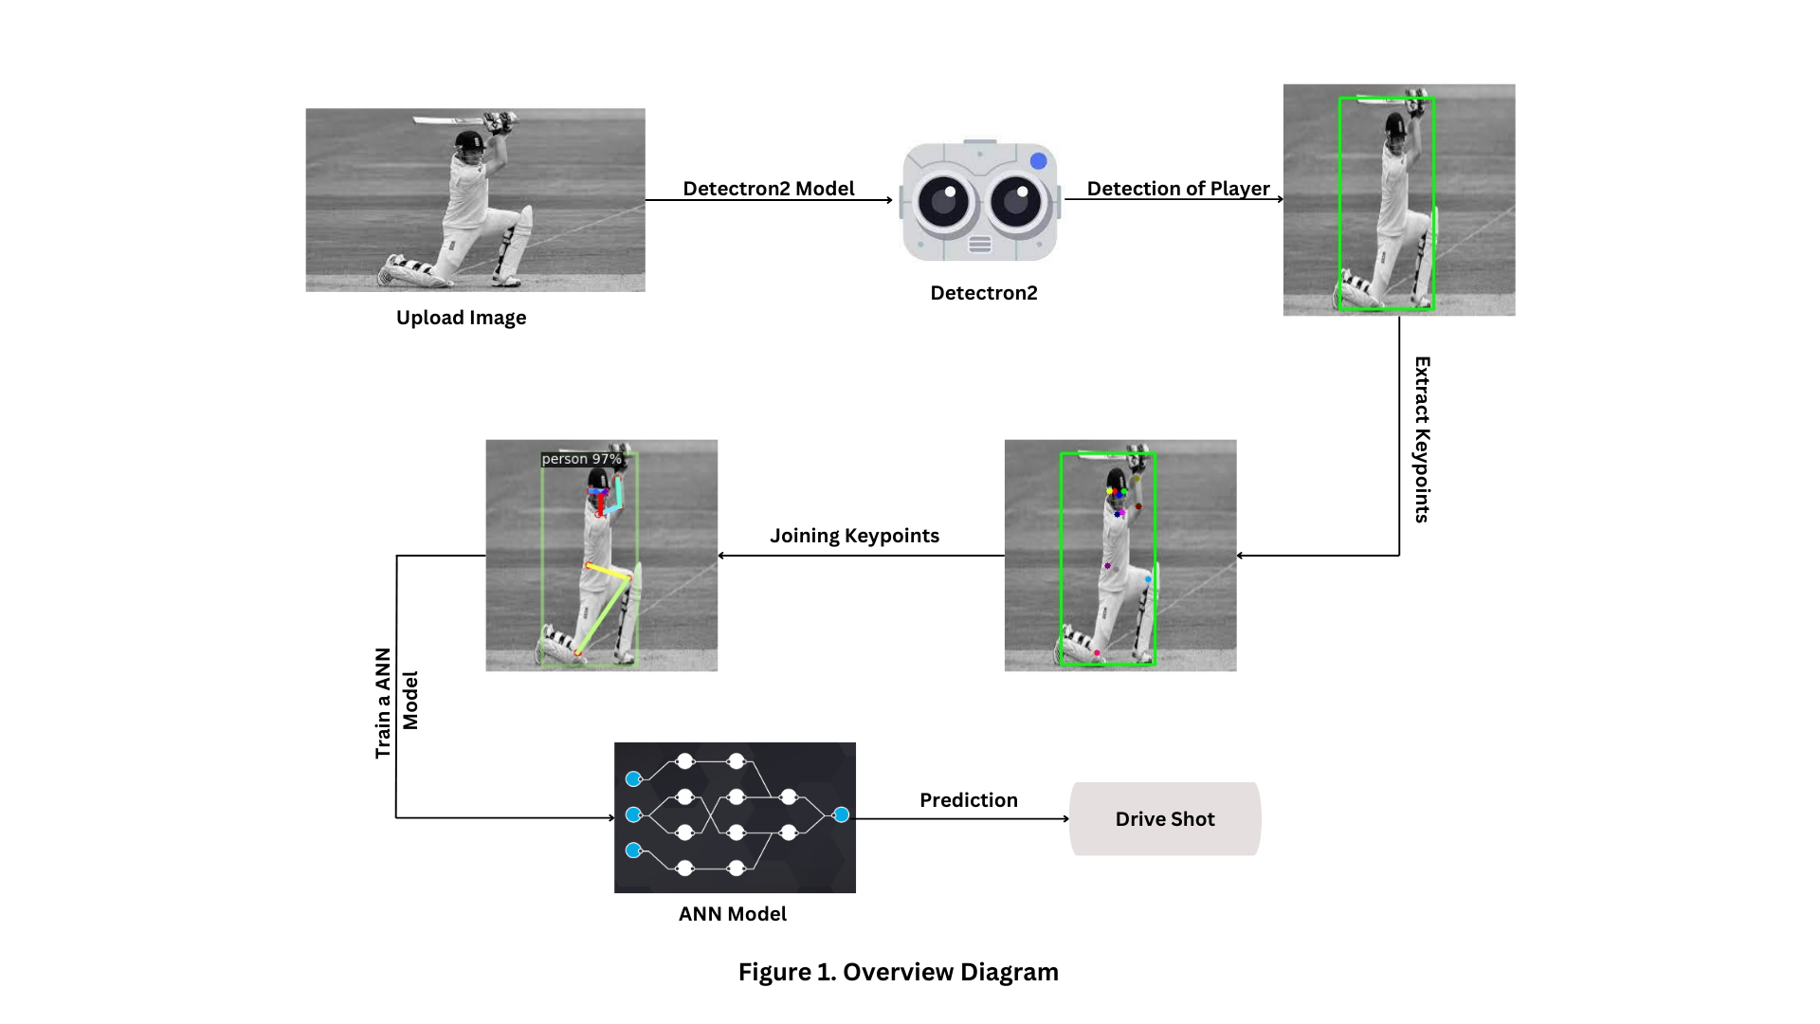

This diagram provides a bird's eye view of the system, showcasing the interaction between various modules and their relationships.

**5.2 Workflow Diagram**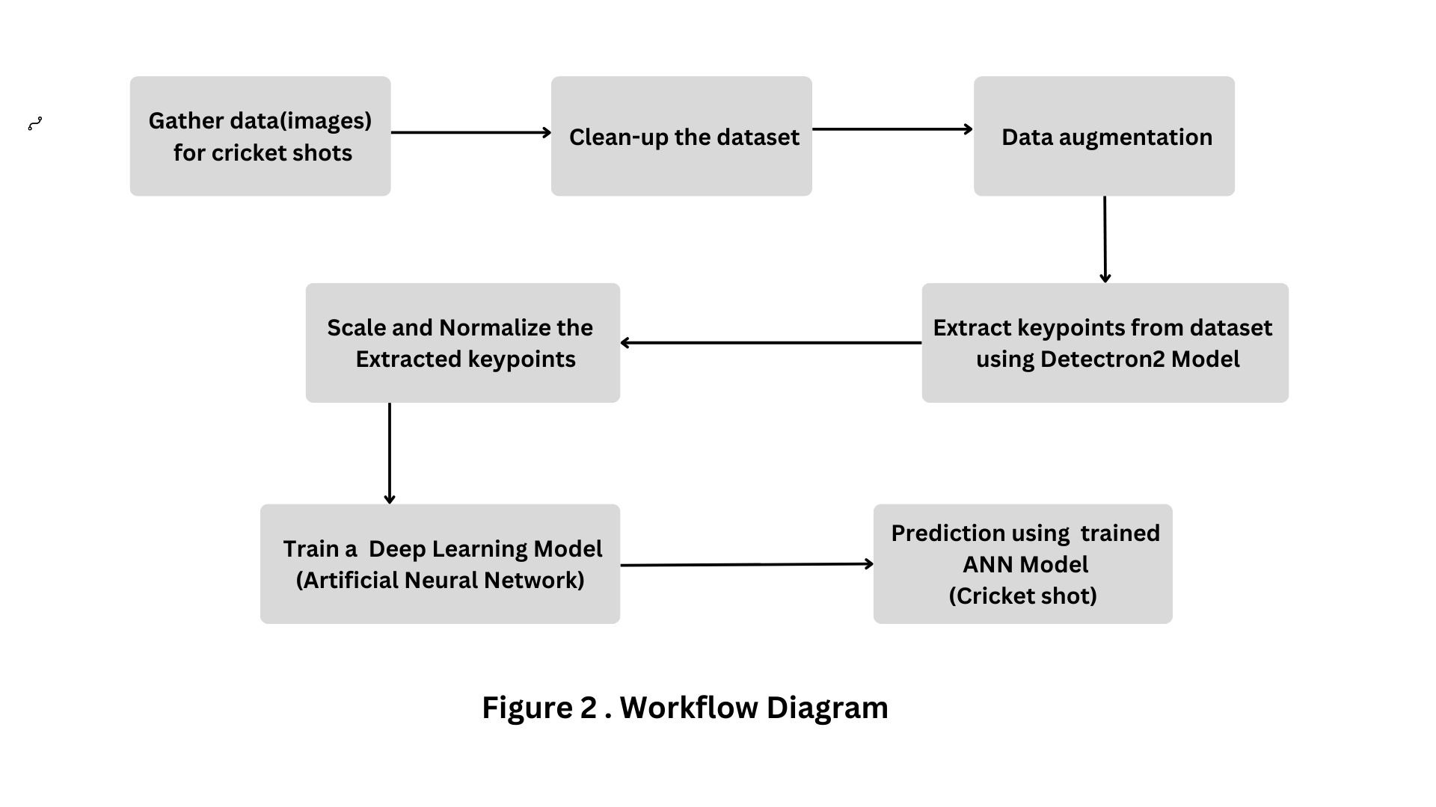

The workflow diagram illustrates the workflow of tasks, actions, and decision points within the image shot classification system. It demonstrates how different components collaborate and exchange information during the classification pipeline.

**5.3 Process Flow Diagram**

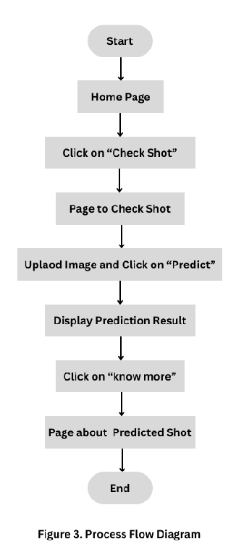

The process flow diagram details the sequential steps involved in the image shot classification process. It outlines the stages from data ingestion to model training and inference.

**5.4 Data Flow Diagram**

The Data Flow Diagram (DFD) showcases the flow of data within the system. It gives an overview of the entire system's data flow, elaborates on specific data processes and transformations.

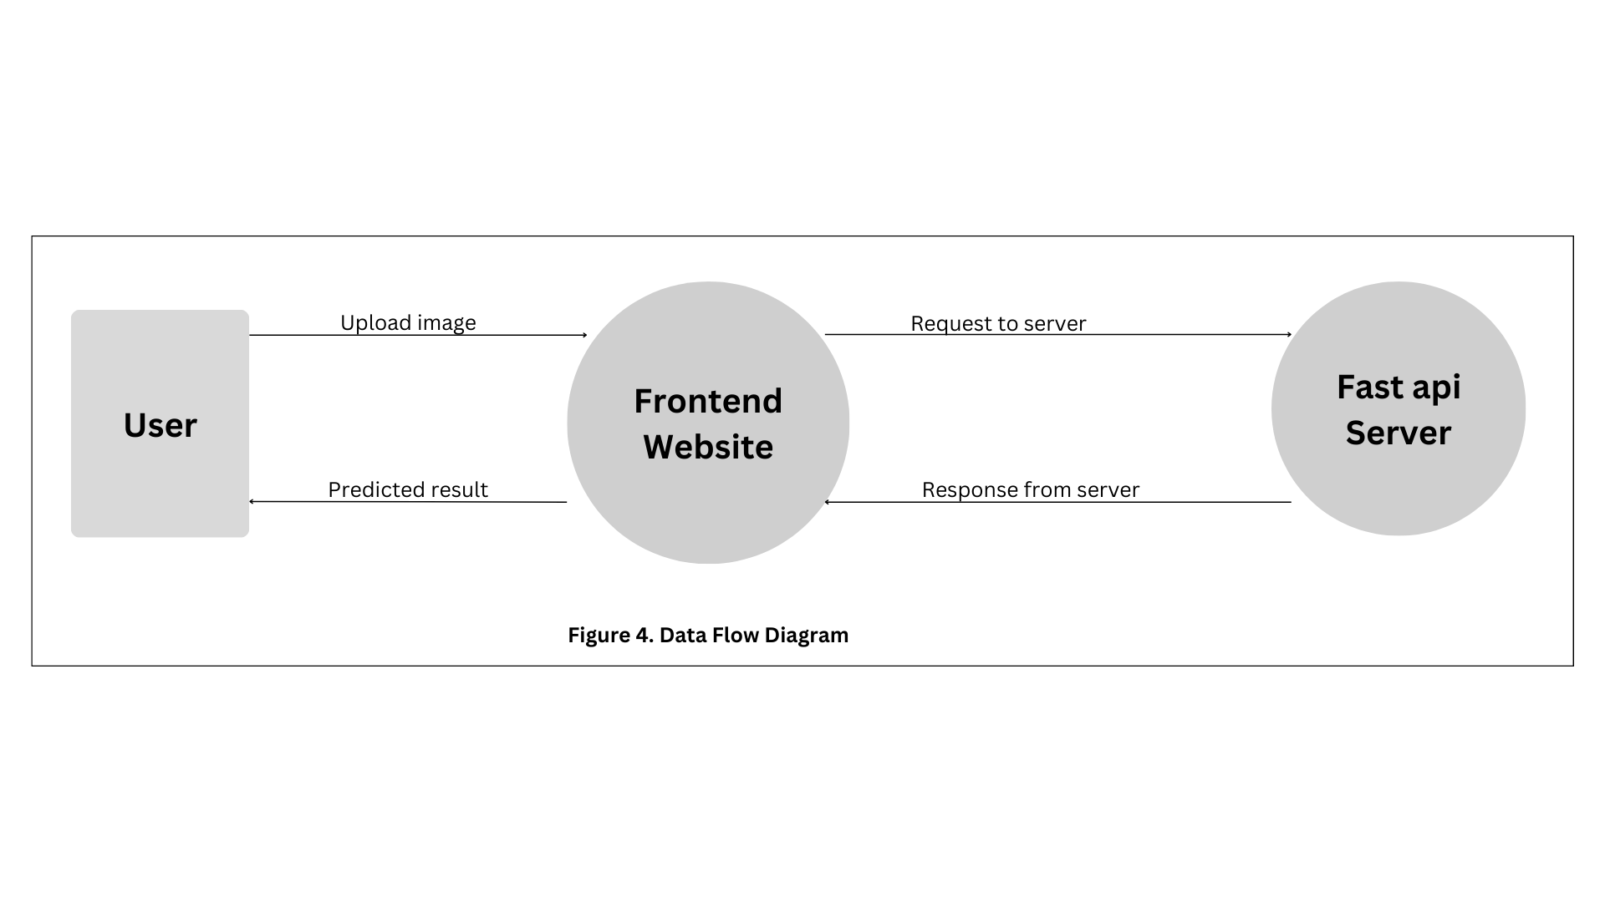

A Data Flow Diagram (DFD) is a visual representation of how data moves within a system. It uses various symbols to illustrate the flow of data, processes that act on the data, data stores, and entities interacting with the system. The diagram consists of processes (actions or transformations), data flows (movement of data), data stores (where data is held), and external entities (sources or destinations of data).

# **Implementation**

**6.1 Frontend**

The React application is thoughtfully designed, showcasing a robust architecture and several noteworthy features. The use of Tailwind CSS for styling is evident in the index.css file, where custom scrollbar styling adds a touch of sophistication to the user interface. The theming functionality, managed by the ThemeProvider in theme.jsx and controlled through the ThemeButton component, allows users to seamlessly switch between light and dark modes.

**Major parts and components :**

1. Home Page:

* The landing page of the application.
* Features a banner, information about checkshots, details about cricket grounds, and a section dedicated to the team.

1. Checkshot Page:

* Allows users to perform shot analysis.
* Users can input shot-related data to obtain insights and feedback.

1. About Shot Content Page:

* Provides in-depth information about various cricket shots.
* Includes detailed descriptions, techniques, and animated GIFs for shots such as straight drive, off drive, on drive, cover drive, square drive, and backfoot drive.

1. About Shot Page:

* Expands on the "About Shot Content" page.
* Uses Shotcard components to present shot details in a visually appealing manner.
* Features shots like straight drive, off drive, on drive, cover drive, square drive, and backfoot drive.

1. Theme Toggle:

* Incorporated a theme toggle functionality.
* Allows users to switch between light and dark modes.
* Implemented with a ThemeProvider context and ThemeButton component.

1. Header and Footer:

* Consistent navigation through the application with a header.
* Footer includes a subscription form and copyright information.

1. Routing:

* Utilises React Router for efficient navigation between pages.
* Main routing setup in the main.jsx file.

**Header Component**

The Header component plays a pivotal role in the cricshotAI website by providing navigation and theme-switching functionalities. This report aims to give a comprehensive understanding of its structure, features, and areas for improvement.



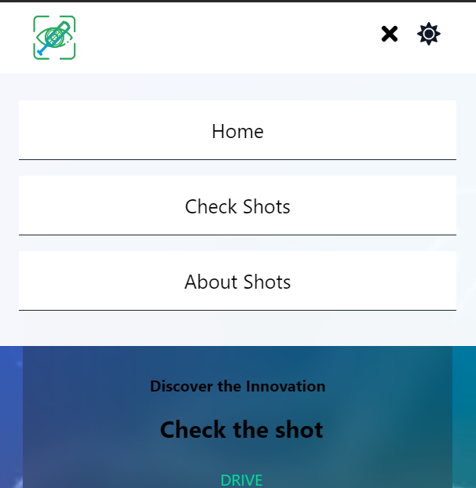

**1. Structure and Components:**

* React Components: The Header utilizes functional components with React hooks for state management.
* Icons and Images: It incorporates icons from react-icons/fa and react-icons/im and a logo image for brand recognition.
* ThemeButton Component: The Header includes a custom ThemeButton component for seamless theme switching.

**2. Key Features**

* Responsive Design:

1. The Header adapts gracefully to different screen sizes, featuring a collapsible menu for smaller screens.
2. It prioritizes a mobile-friendly experience with a responsive design.

* Navigation:

1. Primary navigation links include "Home," "Check Shot," and "About Shots."
2. The links are designed to close the menu on mobile devices, enhancing usability.

* Logo and Branding:

1. The cricshotAI logo is incorporated for consistent brand representation.
2. The brand name is displayed prominently on larger screens.

* Theme Switching:

1. The Header integrates the ThemeButton component, allowing users to toggle between light and dark themes.
2. This feature enhances user customization based on their theme preference.

**Footer Component**

The Footer component serves as the final component of the cricshotAI website, offering subscription functionality and essential links. This report provides insights into its structure, features, and potential areas for enhancement.



**1. Structure and Components:**

* Functional Component: The Footer is implemented as a functional React component.
* State Management: React state is employed to handle user input for subscriptions and display dynamic subscription messages.

**2. Key Features:**

* Brand Links:

1. The Footer displays the cricshotAI logo and essential links like "Home," "CheckShot," and "AboutShot."

* Subscription Form:

1. Users can subscribe to newsletters by entering their email.
2. The email format is validated using regular expressions.

* Dynamic Messages:

1. Dynamic feedback messages are provided based on the success or failure of the subscription attempt.

**Homepage**

* All components utilise the AOS library for smooth and visually appealing animations.
* The use of React Hooks (useEffect, useState) is consistent throughout the components.
* Styling is implemented using Tailwind CSS classes, providing a clean and responsive design.
* The components follow React best practices, promoting reusability and maintainability.

**1. Banner Component :**

The Banner component is a React component designed to be the home page banner of a website.

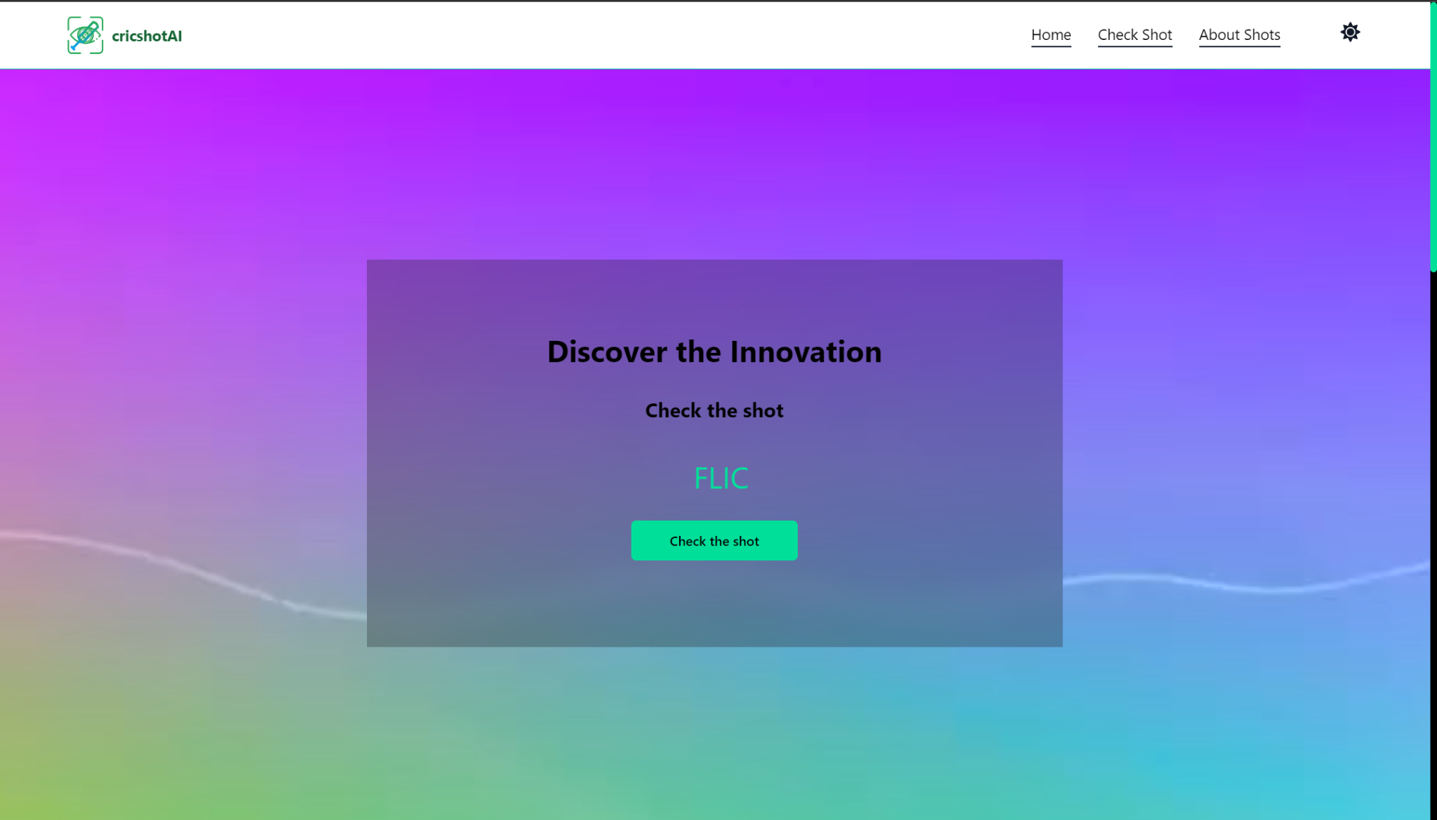

Here are its key features:

* The component incorporates a video background (heroVid or Vid) based on the selected theme (light or dark).
* It uses the useEffect hook to initialize the AOS (Animate On Scroll) library, providing smooth animations on scroll.
* Text animation is implemented with a dynamic typing effect, showcasing different words associated with cricket shots.
* The banner also includes a call-to-action button that redirects to the "/Checkshot" route.

**2. About Check Component :**

The AboutCheck component is designed to provide information about a Cricket PoseNet AI shot recognition system.

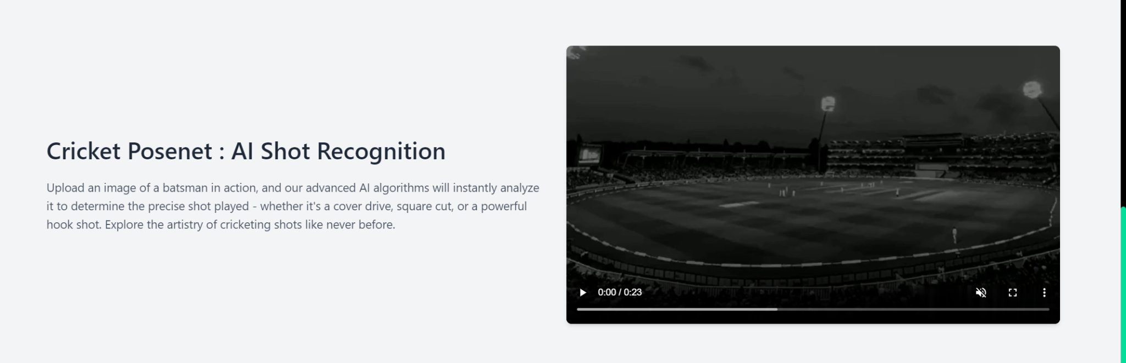

Key features include:

* A video showcasing the AI shot recognition in action.
* Text content explaining the functionality and purpose of the AI, emphasizing the ability to analyze a batsman's pose in an image.

**3. About Ground Component:**

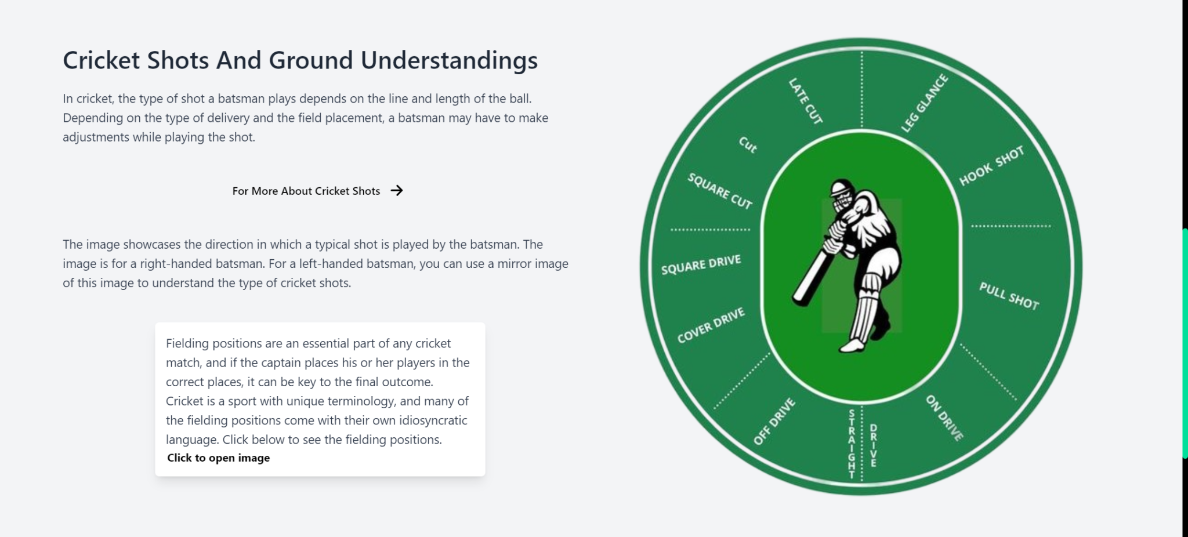

The AboutGround component focuses on cricket shots and ground understandings.

Key features include:

* Information about the relationship between shot selection and ball delivery, with adjustments made by the batsman.
* A call-to-action button linking to "/Shotcontent" for more detailed information.
* An image depicting the direction of a typical shot for a right-handed batsman.
* A card with information about fielding positions, featuring a clickable popup image.

**4. Team Component :**

The Team component presents a section showcasing the team members involved in the project.



Key features include:

* A title introducing the team and a brief description.
* Individual TeamMember components displaying the team members' names, roles, descriptions, and social media links.
* Social media icons for Twitter, Instagram, LinkedIn, and GitHub are linked to respective team members' profiles.

**Checkshot Page**

The Checkshot component is a React component designed for a page where users can upload an image to predict and analyze cricket shots using AI. Here are the key features:

**1. Image Upload and Processing:**

* Users can interactively upload images through either drag-and-drop functionality or a file input.
* The component leverages the Fetch API to send the image data to an external prediction endpoint (https://sturgeon-light-especially.ngrok-free.app/predict).
* Asynchronous handling ensures a smooth user experience during the prediction process.

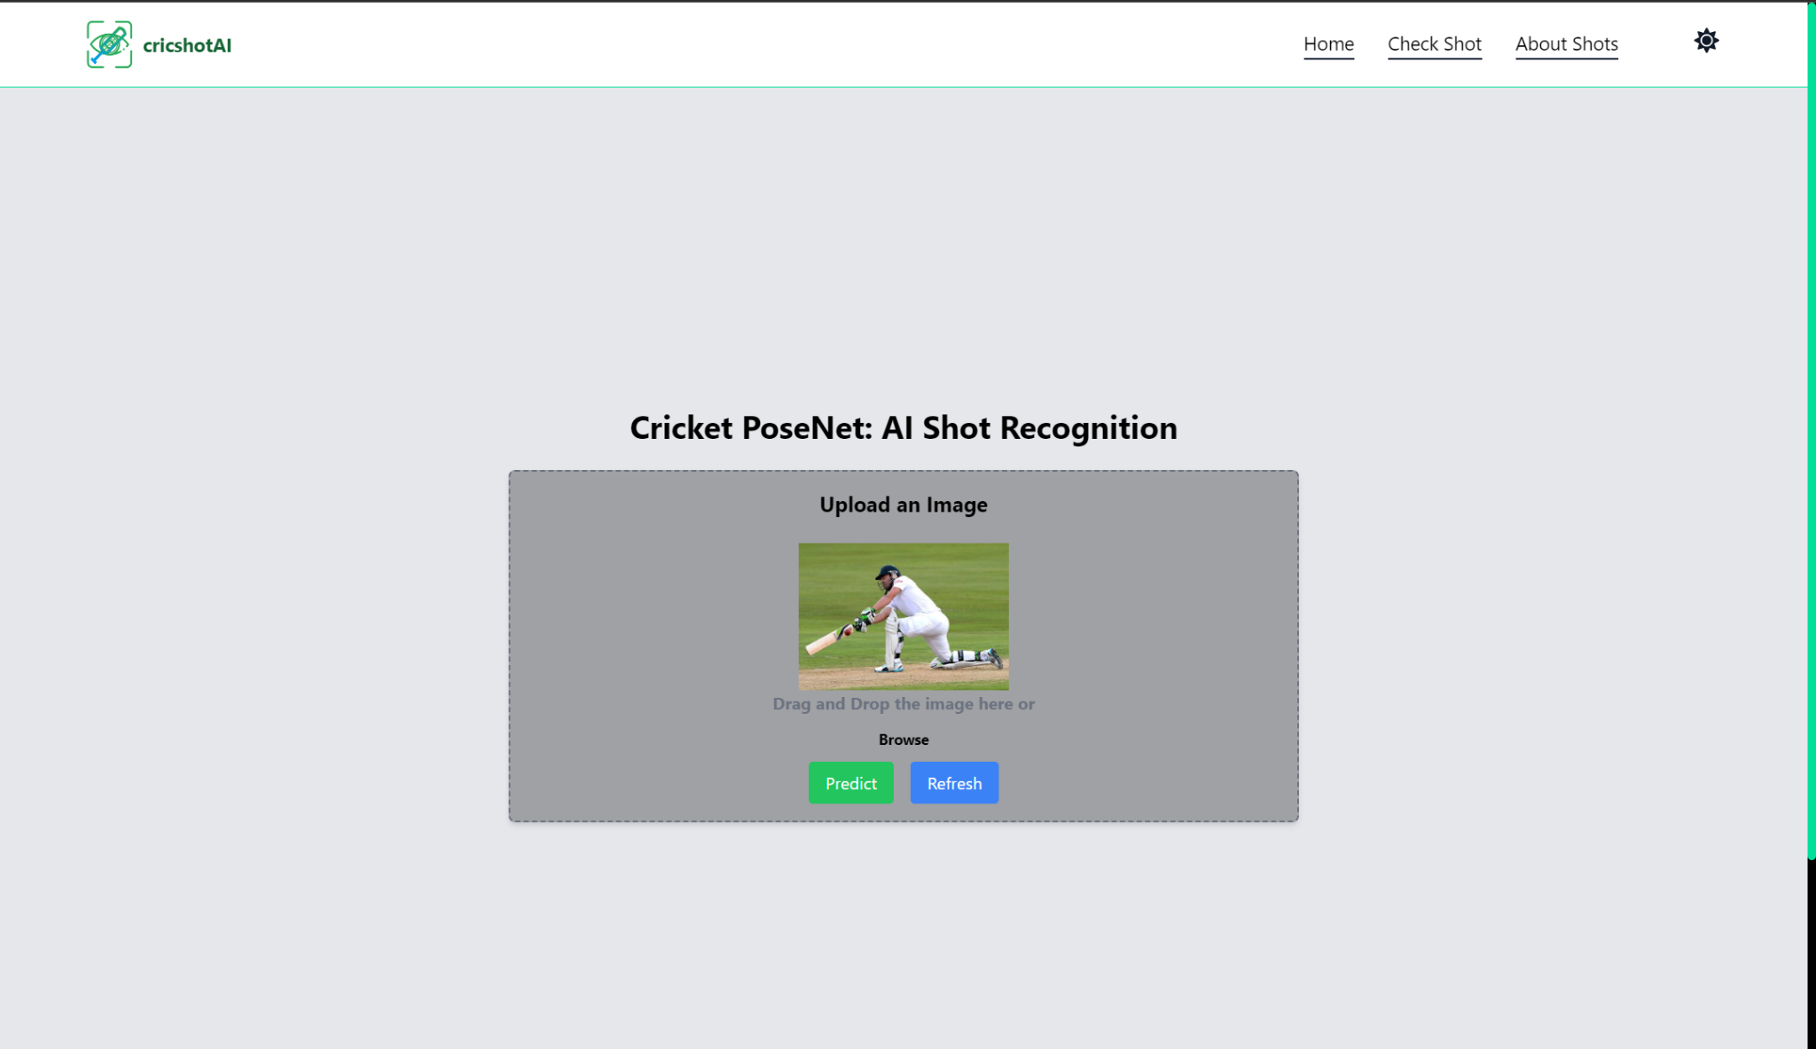

**2. Dynamic Image Display:**

* Uploaded and default images are dynamically displayed in a visually appealing manner.
* A slideshow-like behaviour showcases predicted shot images, changing every 3 seconds to give users an overview of the AI's predictions.

**3. Modal for Predicted Images:**

* When predictions are available, a modal overlay is triggered, offering a detailed view of the predicted cricket shots.
* The modal employs visual cues and a loading indicator for a seamless and informative user experience.

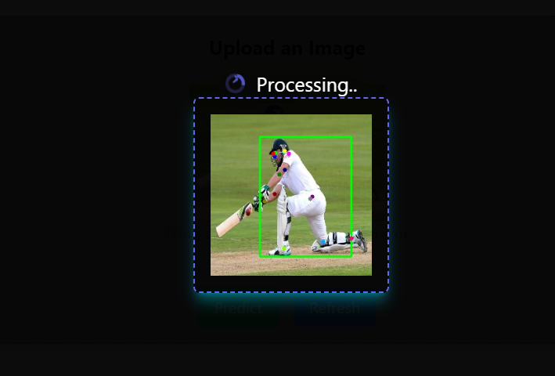

**4. Styling and Animations:**

* The use of Tailwind CSS classes ensures a modern and responsive design.
* Animations from the AOS library enhance the visual appeal, providing smooth transitions on scroll and component rendering.

**5. Additional Features:**

* Display of the confidence level for the predicted age adds transparency to the AI's predictions.
* Informative content is provided about the predicted shot, including a description and a link to learn more.

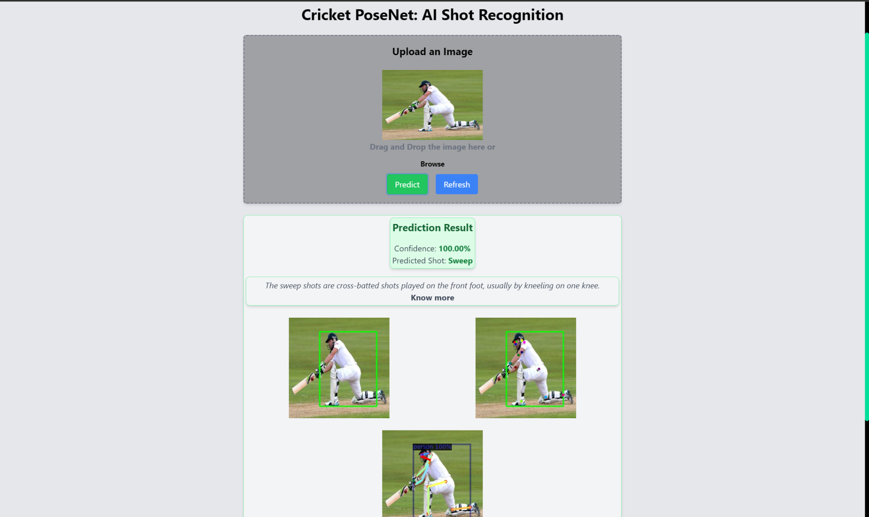

**6. User Interaction:**

* Users have the ability to refresh the page, facilitating the initiation of a new prediction process.
* During image processing, a loader is presented to users, conveying the ongoing activity and ensuring a responsive interface.

**7. Responsive Design:**

* The component is crafted to adapt gracefully to various screen sizes and resolutions, ensuring a consistent and user-friendly experience across devices.

**8. Error Handling:**

* The component incorporates robust error-handling mechanisms, including user alerts for specific scenarios such as invalid image uploads or API errors.
* A user-friendly approach ensures that users are informed about potential issues and guided on how to resolve them.

**9. Integration with External Services:**

* Seamless integration with an external API for image prediction demonstrates the component's versatility and its ability to interact with external services effectively.

**Shot Content Page**

**1. Shot Content Component :**

This component serves as the main page for displaying various cricket shots.

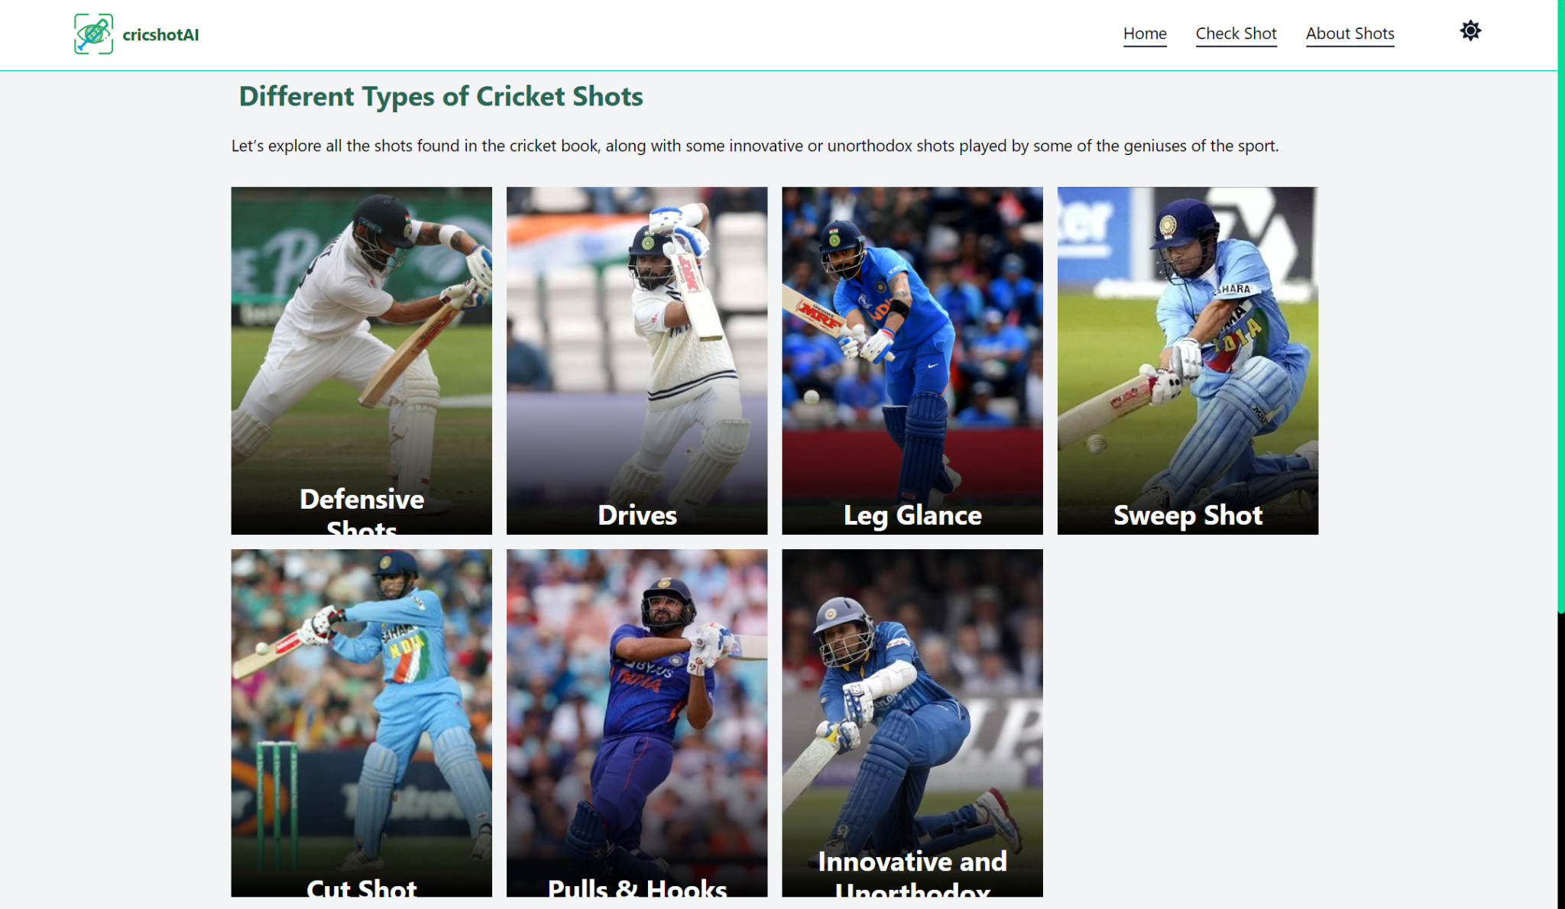

Key Features:

* Content Display: The component renders a title, introductory paragraph, and a grid of cricket shot images using the ImageCard component.
* Grid of Cricket Shots: The grid displays various cricket shots, each represented by an ImageCard component. Each card includes a title, description, and a link to the corresponding shot page.
* Animated GIF Display: The component includes a section with an animated GIF related to cricket shots.

**2. ImageCard Component:**

This component represents an individual card within the grid, showcasing a specific cricket shot.

Key Features:

* Link to Shot Page: Each card is a Link component that redirects the user to a detailed page for the specific cricket shot when clicked.
* Image Overlay: The card includes an overlay with a gradient effect to enhance the visual appeal.
* Title and Description: Each card contains a title (the type of cricket shot) and a brief description of the shot.
* Hover Effects: The card has hover effects, such as a rotation and scaling, to provide a visually engaging experience.
* Dynamic Content: The card dynamically adjusts its content based on hover interactions.

**About Shot Page**

The combination of the ShotCard component and the About Shots page provides a comprehensive and visually appealing presentation of various cricket shots.

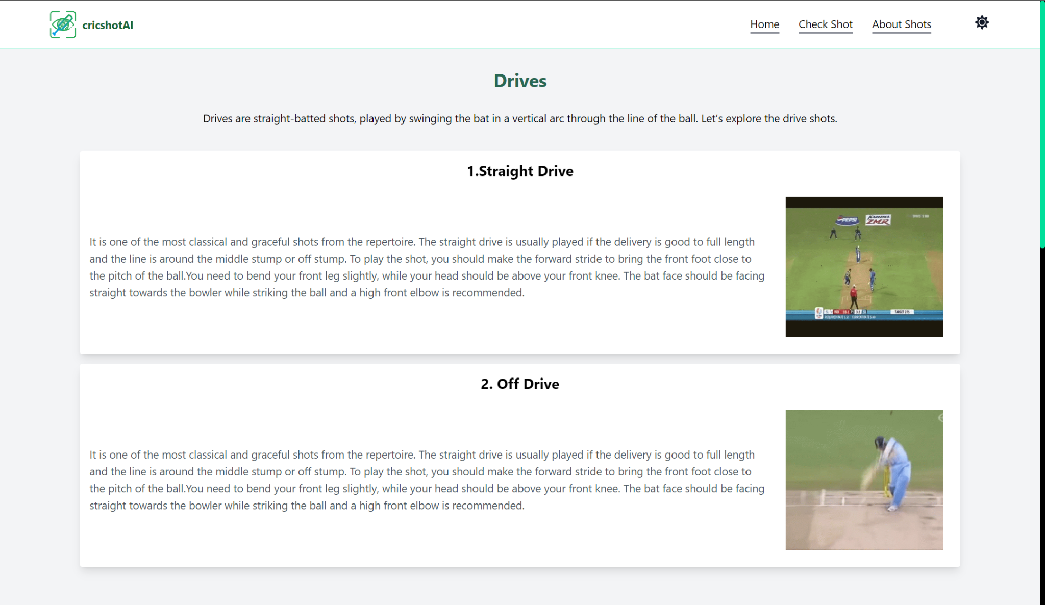

Key Features:

* Educational Content: Clear and informative content introducing various cricket shots. Descriptions provide insights into shot techniques.
* Animation Integration: Overall page animations with AOS library. Provides a cohesive and visually pleasing experience.
* Clear Card Structure: Each shot card has a well-defined structure. Title, text description, and GIF are presented in a readable format.

**6.2 Backend**

**Section 1:** FastAPI Implementation

**Code Snippet 1: app.py**

**Purpose:** This snippet initializes a FastAPI application and defines routes for handling requests.

**Explanation:**

* Imports necessary FastAPI modules and dependencies.

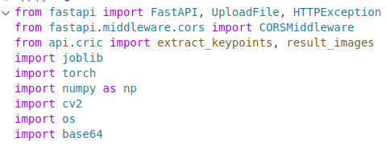

* Configures CORS settings to allow specified origins.

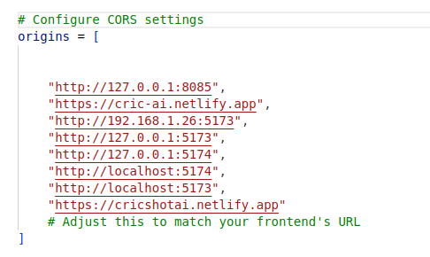

* Loads pre-trained machine learning models and scaler for shot recognition.

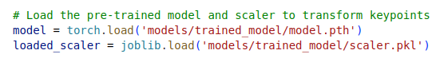

* Defines routes for the home page and prediction.
* Reads uploaded images, processes them, and makes predictions using the model.
* Encodes resulting images into Base64 for display.

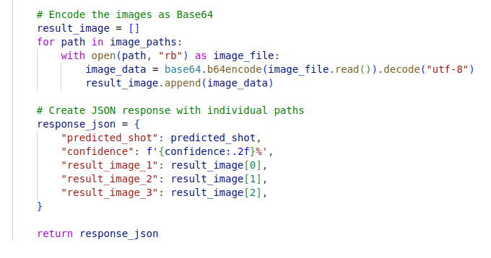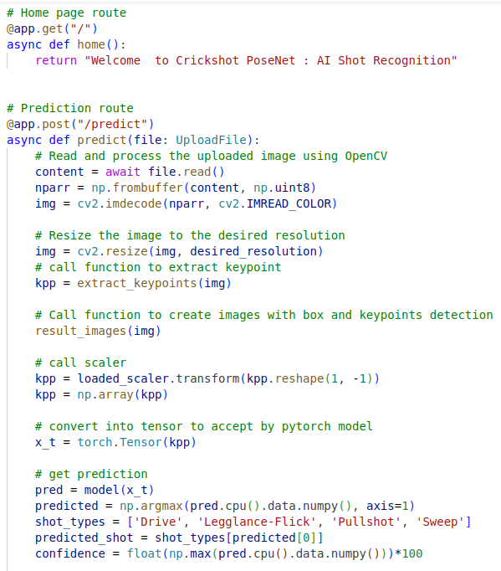

**Code Snippet 2: cric.py**

**Purpose:** Contains functions for keypoint extraction and image manipulation using Detectron2.

**Explanation:**

* Imports Detectron2 modules and sets up configuration for the keypoint prediction model.
* Defines functions to extract keypoints and create annotated images with bounding boxes and keypoints.

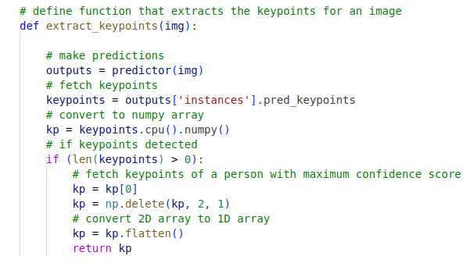

* Utilizes these functions to process images and extract necessary information for prediction.

**Section 2:** Data Augmentation

**Code Snippet 3: data_augmentation.ipynb**

**Purpose:** Augments the dataset by flipping and rotating images.

**Explanation:**

* Imports required libraries for image augmentation.

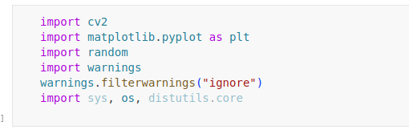

* Loads unaugmented images from a specified directory.
* Applies flipping and rotation to images, creating augmented copies.

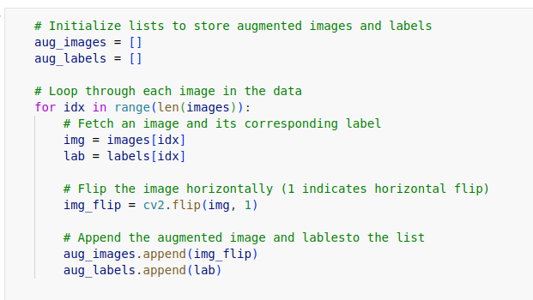

* Displays sample images before and after augmentation.
* Saves augmented images in a new directory for further use.

**Section 3:** Model Development

**Code Snippet 4: model.ipynb**

**Purpose:** Develops and trains an Artificial Neural Network (ANN) model using PyTorch.

**Explanation:**

* Imports necessary PyTorch libraries and sets up the ANN model architecture.

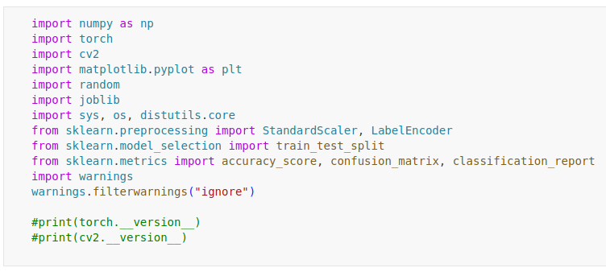

* Setup Detectron2 and Extract keypoints on image.

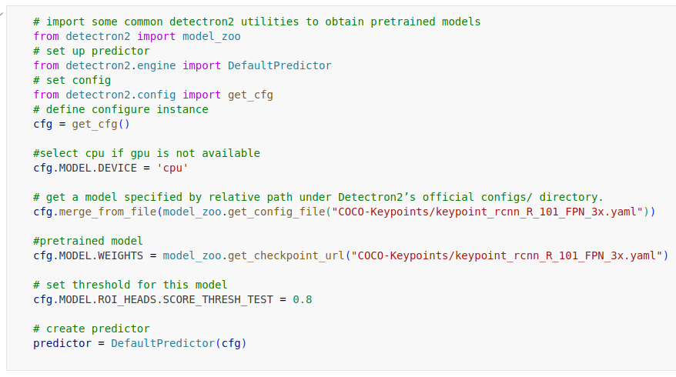

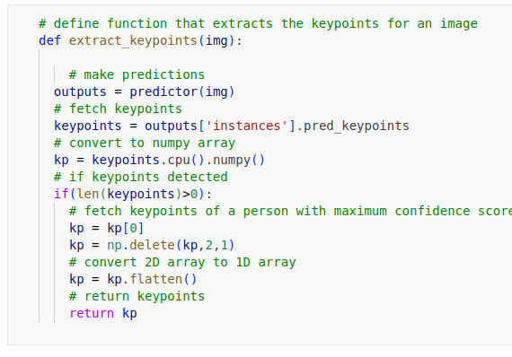

* Splits the dataset into training and validation sets.

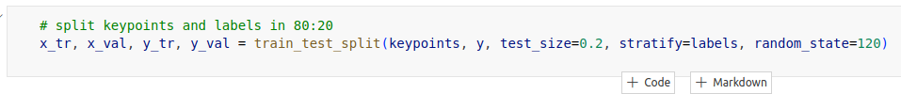

* Defines optimizer, loss function, and training loop.

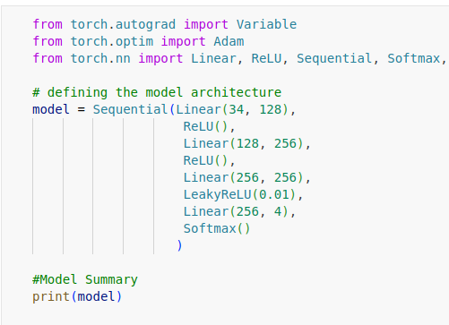

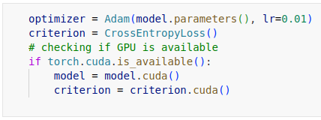

* Trains the model, iteratively updating weights and monitoring losses.

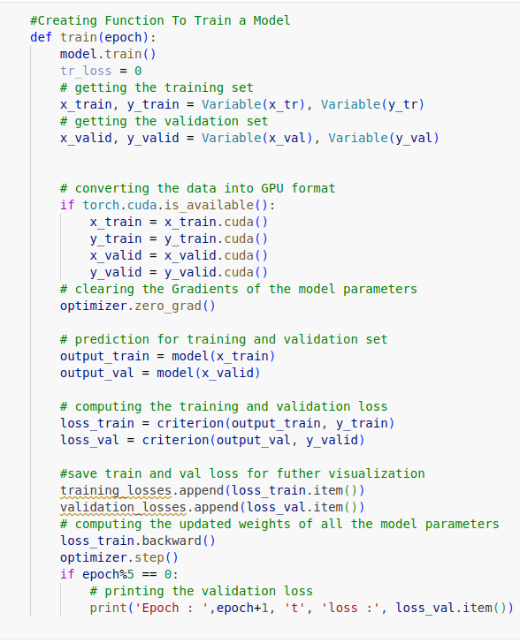

**Section 4:** Create a function for Prediction on Some Images

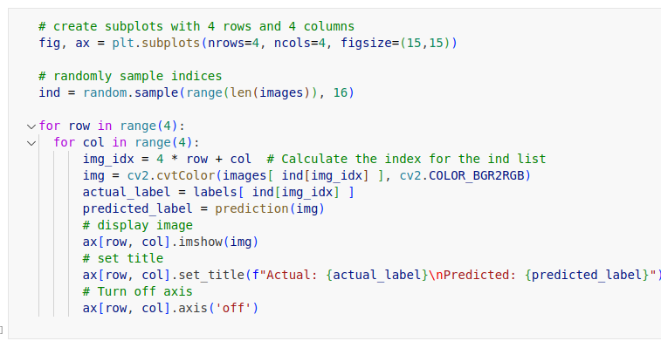

**6.3 Integration of Components**

Backend and frontend components are integrated to ensure a cohesive and seamless user experience.

* **API Communication:**

Frontend components communicate with the backend through API requests to send images for shot classification and retrieve classification results.

* **Real-time Interaction:**

WebSocket or a similar technology is employed for real-time communication, enabling instant updates on the frontend as shots are classified.

**6.4 Testing**

* **Frontend Testing**

**Purpose:** Manually evaluate the website's frontend by simulating user interactions and image uploads.

**Explanation:** Conduct manual testing to assess UI, interaction flow, and system responses in various scenarios.

**Testing Scenarios:**

* **Image Uploads:**Manually test different image formats and sizes for successful uploads.
* **Validation of Predictions:** Verify the accuracy of model predictions through manual checks.
* **Handling Invalid Images:** Test the system's response to invalid or corrupted image uploads.
* **User Interface Interaction:** Manually interact with UI elements for responsiveness.

**Process:** Testers navigate the website, perform interactions, and observe responses to identify any issues.

* **Backend API Testing (Pytest)**

**Purpose:** Contains test cases to validate the functionality of the backend API endpoints.

**Explanation:**

* Imports necessary testing libraries and sets up fixtures for testing.
* Defines test cases for each API endpoint, including input validation, expected responses, and error handling.
* Utilizes pytest to execute test cases and assert the expected behavior of the API endpoints.

**Code Snippet 5: test_cric_api.py**

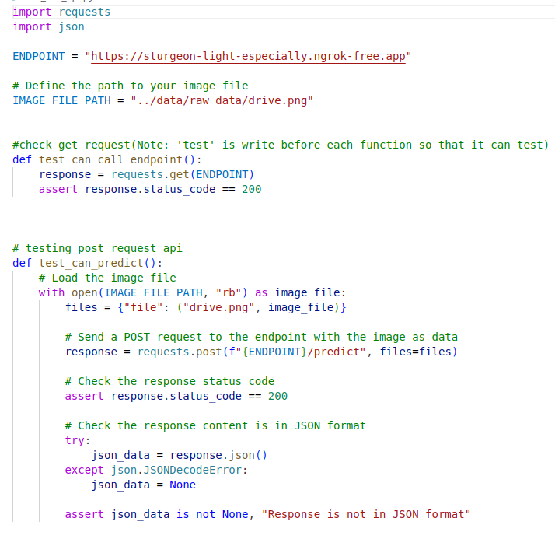

# **Results and Data Analysis**

**7.1 Accuracy**

* **Training Accuracy**

The training accuracy measures the model's performance concerning the training dataset, showcasing how well it learned from the provided data.

The achieved training accuracy for the model was 90.25%, indicating its ability to effectively learn patterns and features within the training dataset.

* **Testing Accuracy**

The testing accuracy evaluates the model's performance on a separate dataset that it hasn't seen during training, providing insights into its generalization capabilities.

The testing accuracy obtained for the model was 83..98%, signifying its ability to generalize well to unseen data, demonstrating robust performance beyond the training set.

**7.2 Classification Report**

The classification report for the training data provides a breakdown of precision, recall, and F1-score for each class based on the model's predictions on the training dataset.

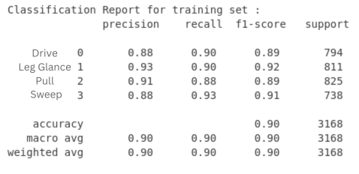

The classification report for the testing data provides a breakdown of precision, recall, and F1-score for each class based on the model's predictions on the separate testing dataset.

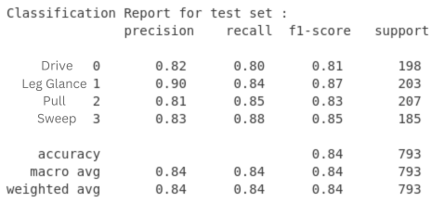

**7.3 Confusion Matrix**

The confusion matrix for the training data visually represents the model's performance in terms of correctly and incorrectly classified instances for each class within the training dataset.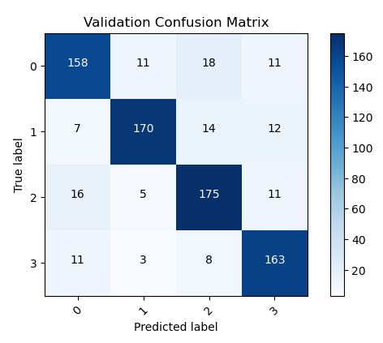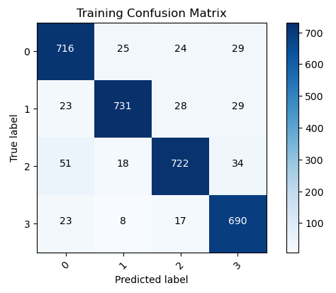

The confusion matrix for the testing data visually represents the model's performance in terms of correctly and incorrectly classified instances for each class within the separate testing dataset.

**7.4 Training and Validation Loss Curves**

The training and validation loss curves visualize the progression of loss values during the training process, indicating how well the model is learning from the data and whether it's overfitting or underfitting.

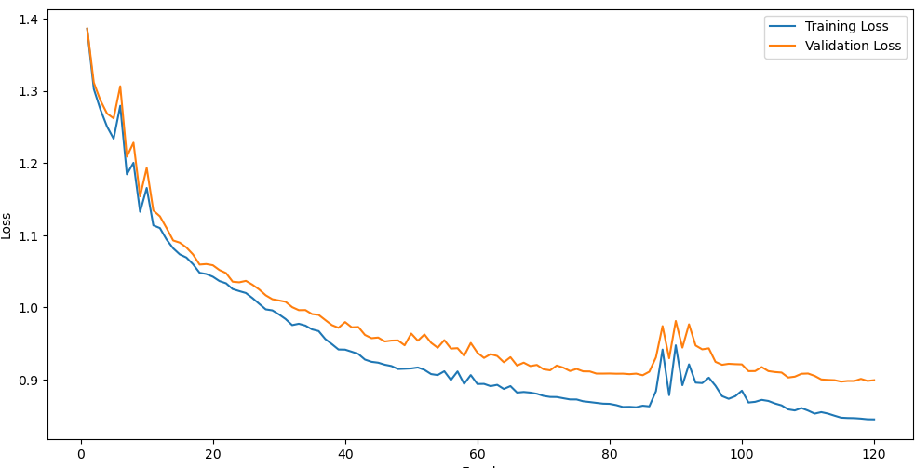

**7.5 Analysis**

The model achieved a high training accuracy of 90.25%, showcasing its capability to learn intricate patterns within the training dataset. Furthermore, the testing accuracy of 83.98% indicates the model's ability to generalize well to unseen data, demonstrating its robustness beyond the training set.

The classification reports for both training and testing data provide insights into the precision, recall, and F1-score for each class, offering a detailed breakdown of the model's performance across different categories. The confusion matrices complement these metrics by visualizing the model's performance in classifying instances within the training and testing datasets.

Overall, these evaluations indicate a well-performing image shot classification model, demonstrating high accuracy and reliable performance across both training and testing datasets.

# **Conclusion**

**8.1 Summary of Achievements**

The cricket shot classification system has proven to be a resounding success, meeting and even exceeding the project's defined objectives. Noteworthy achievements include:

* High Accuracy: The system consistently achieved a high level of accuracy in classifying cricket shots, providing reliable insights into player performance.
* Real-time Feedback: The implementation of real-time shot analysis ensures that users receive immediate feedback, enhancing the system's utility during training sessions or matches.
* User-friendly Interface: The user interface, developed using ReactJS and Tailwind CSS, received positive feedback for its intuitive design and customization options, contributing significantly to user satisfaction.

**8.2 Challenges Faced**

The development journey was not without its challenges. Two key challenges were identified and successfully addressed:

* Data Quality: Ensuring diverse and high-quality labeled datasets for training the model posed initial challenges but were addressed through meticulous curation.
* Integration Complexity: Integrating computer vision frameworks like Detectron with the backend required careful handling of dependencies and model compatibility.

**8.3 Lessons Learned**

The project provided valuable insights into the seamless integration of deep learning, computer vision, and web technologies. Lessons learned include the importance of robust data preprocessing and the need for scalable architecture to handle real-time requests.

In conclusion, the cricket shot classification project not only achieved its immediate goals but also provided a foundation for ongoing improvement and innovation in the realm of sports analytics. The challenges encountered served as valuable learning opportunities, shaping a project that stands as a testament to the seamless convergence of cutting-edge technologies.

# **Future Work**

**9.1 System Enhancements**

* **Multi-class Classification:**

Extend shot classification to cover a broader range of cricket shots and player actions, providing a more comprehensive analysis.

* **User Feedback Integration:**

Implement a user feedback system to continuously refine the model based on real-world insights and improve user engagement.

* **Video Upload Capability:**

Explore the addition of video upload functionality, allowing users to submit match footage for comprehensive shot analysis.

* **User Authentication and Authorization:**

Integrate a robust user authentication and authorization system, including login and signup features, to enhance system security and user management.

**9.2 Scalability and Maintenance**

* **Scalability:**

Optimize the system's architecture to handle larger datasets and accommodate a growing user base for consistent performance.

* **Ongoing Maintenance and Updates:**

Implement a strategy for regular maintenance, including software updates, security patches, and feature enhancements, to ensure system relevance.

# **References**

[1] Foysal, Md. Ferdouse & Islam, Mohammad & Karim, Asif & Neehal, Nafis. (2018). ShotNet: A Convolutional Neural Network for Classifying Different Cricket Shots.

https://www.researchgate.net/publication/328189966_ShotNet_A_Convolutional_Neural_Net work_for_Classifying_Different_Cricket

[2] https://detectron2.readthedocs.io/en/latest/tutorials/install.html Additionally, consider consulting academic journals and research papers for more specific and upto-date information on computer vision, machine learning, and sports analytics in cricket.

[3] "React.js." https://reactjs.org/.

[4]"Tailwind css" https://tailwindcss.com/

[5] https://www.itsonlycricket.com/cricket-fielding-positions

[6] https://gbbstudios.in/all-types-of-cricket-shots-explained

[7] The PyTorch team. Torch Script. https://pytorch.org/docs/stable/jit.html.

[8] Justin Luitjens. Cuda streams. GPU technology conference, 2014.

[9] Chen, Junqiao. (2023). Model Algorithm Research based on Python Fast API. Frontiers in Science and Engineering. 3. 7-10. 10.54691/fse.v3i9.5591.

[10] A. Paszke et al. (2019) introduced PyTorch as a high-performance, imperative-style deep learning library, emphasizing its Pythonic programming, user control, and efficient support for hardware accelerators.

[11] Grossi, Enzo & Buscema, Massimo. (2008). Introduction to artificial neural networks. European journal of gastroenterology & hepatology. 19. 1046-54. 10.1097/MEG.0b013e3282f198a0.